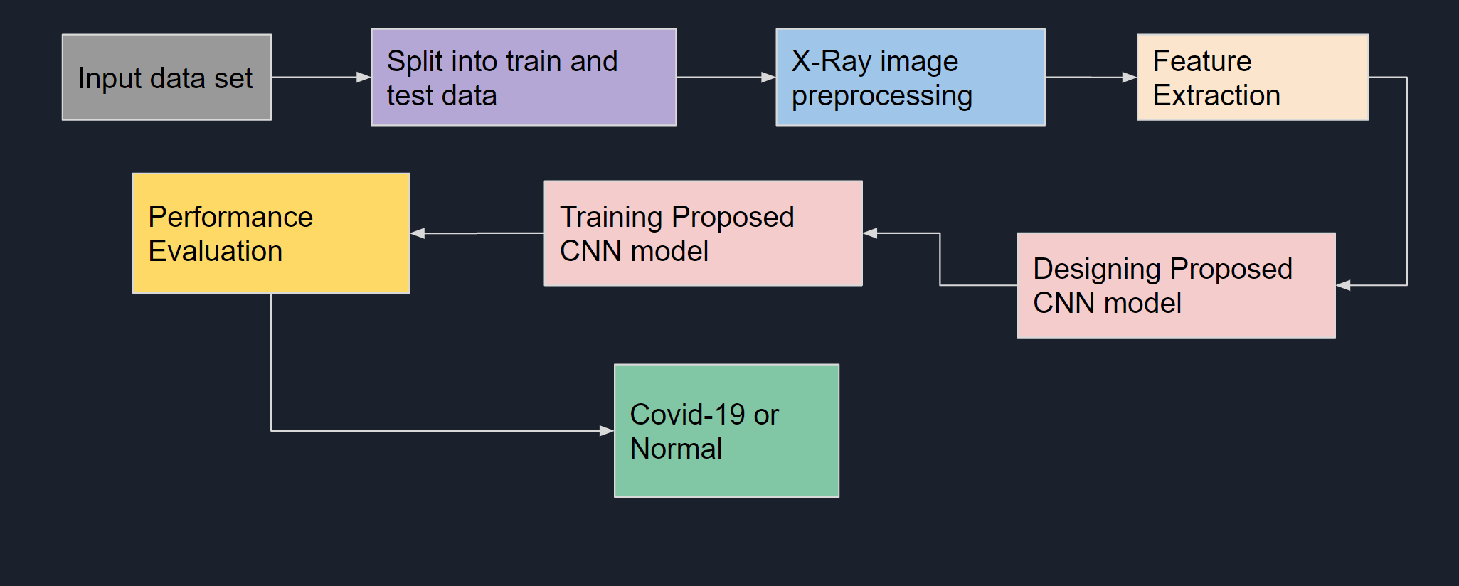

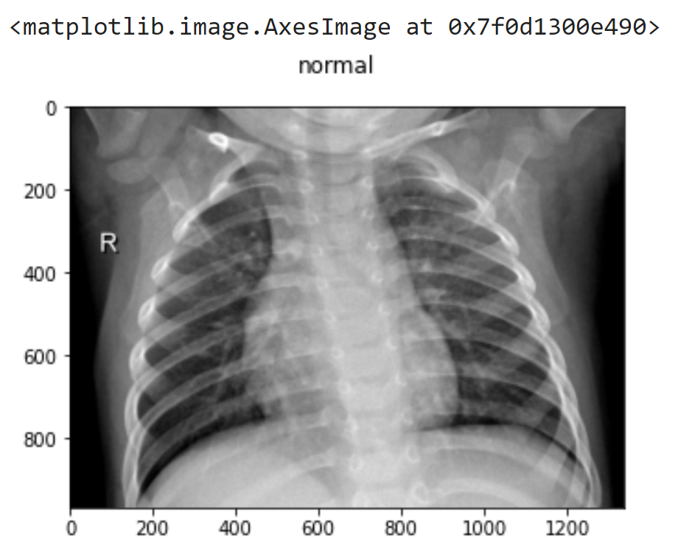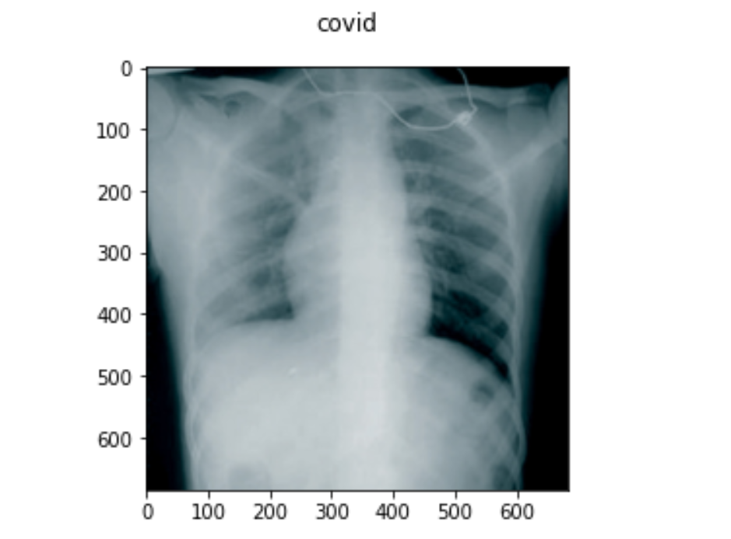

1. (B)

Fig. 2. (A) X-ray image of a normal/healthy human. (B) X-ray image of a COVID-19 infested human.

Model: "sequential_2"

_________________________________________________________________

Layer (type) Output Shape Param #

=================================================================

conv2d_8 (Conv2D) (None, 148, 148, 32) 896

activation_7 (Activation) (None, 148, 148, 32) 0

max_pooling2d_3 (MaxPooling (None, 74, 74, 32) 0

2D)

conv2d_9 (Conv2D) (None, 72, 72, 32) 9248

activation_8 (Activation) (None, 72, 72, 32) 0

max_pooling2d_4 (MaxPooling (None, 36, 36, 32) 0

2D)

conv2d_10 (Conv2D) (None, 34, 34, 64) 18496

activation_9 (Activation) (None, 34, 34, 64) 0

conv2d_11 (Conv2D) (None, 32, 32, 250) 144250

activation_10 (Activation) (None, 32, 32, 250) 0

conv2d_12 (Conv2D) (None, 30, 30, 128) 288128

activation_11 (Activation) (None, 30, 30, 128) 0

average_pooling2d_2 (Averag (None, 15, 15, 128) 0

ePooling2D)

conv2d_13 (Conv2D) (None, 13, 13, 64) 73792

activation_12 (Activation) (None, 13, 13, 64) 0

average_pooling2d_3 (Averag (None, 6, 6, 64) 0 ePooling2D)

conv2d_14 (Conv2D) (None, 5, 5, 256) 65792

activation_13 (Activation) (None, 5, 5, 256) 0

max_pooling2d_5 (MaxPooling (None, 2, 2, 256) 0

2D)

flatten_1 (Flatten) (None, 1024) 0

dense_1 (Dense) (None, 32) 32800

dropout (Dropout) (None, 32) 0

dense_2 (Dense) (None, 1) 33

activation_14 (Activation) (None, 1) 0

=================================================================

Total params: 633,435

Trainable params: 633,435

Non-trainable params: 0

Fig. 3. Sequential model reference [7]

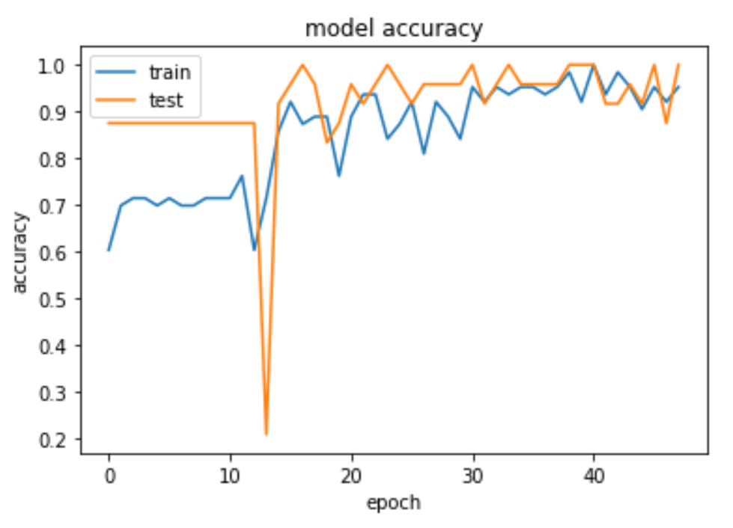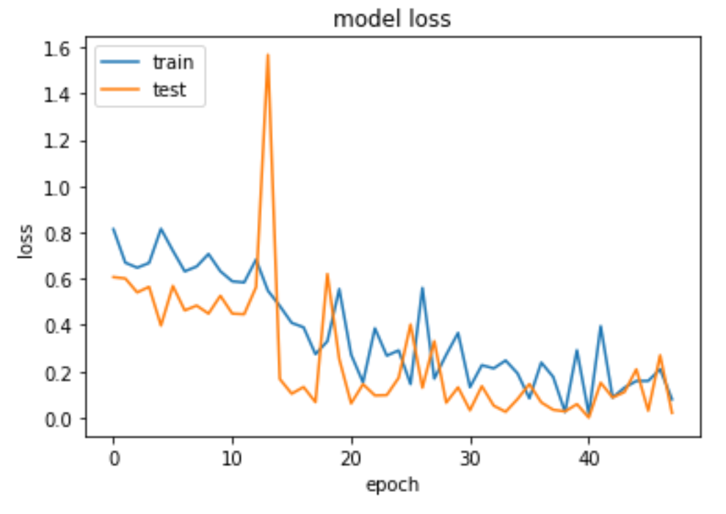

1. (B)

Fig. 4. (A) Model Accuracy of the implemented model [6] (B) Model Loss of the implemented model reference [6]

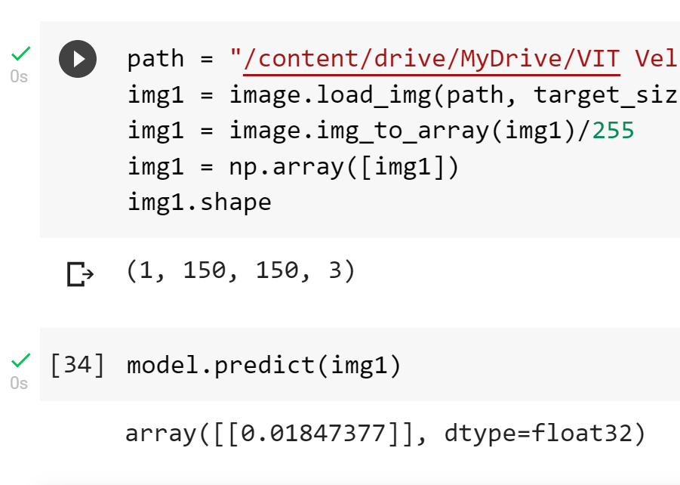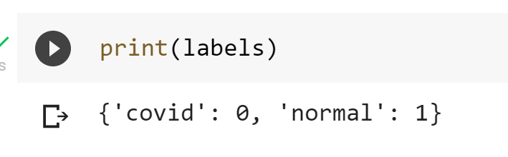

Fig. 6. Model classified a normal image as

COVID-19 infected

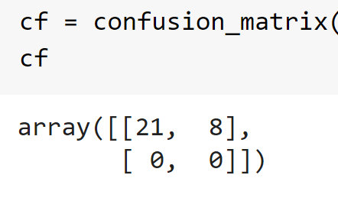 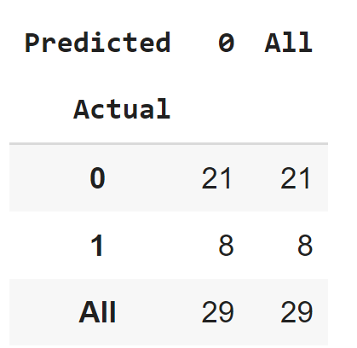 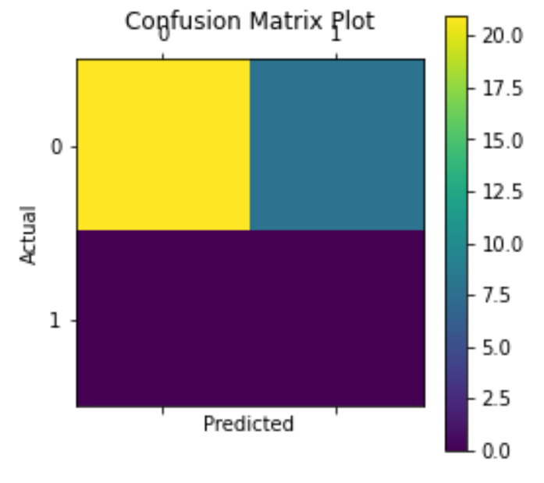

Fig. 5. Different representations of the confusion matrix

Obtained from model reference [6]

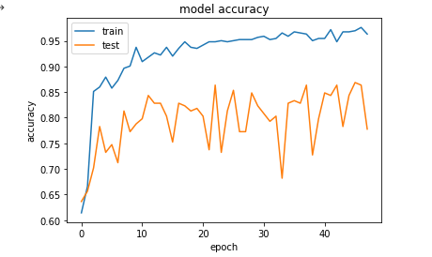 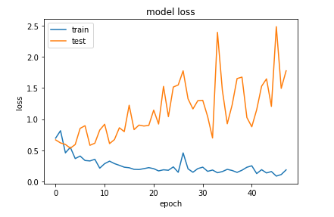

Fig. 7. Model training based on the dataset specification –

Number of COVID-19 X-ray images = 420,

Number of Normal X-ray images = 251

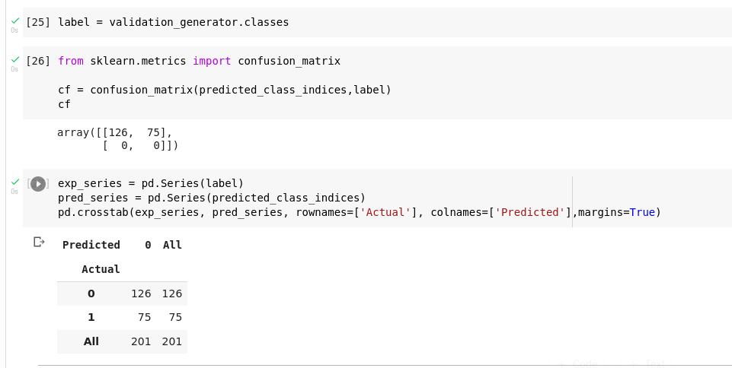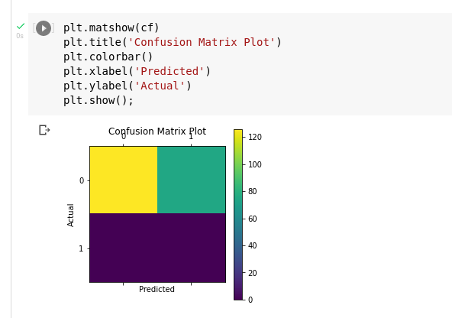

Fig. 8. Different representations of the confusion matrix

based on the dataset specification –

Number of COVID-19 X-ray images = 420,

Number of Normal X-ray images = 251

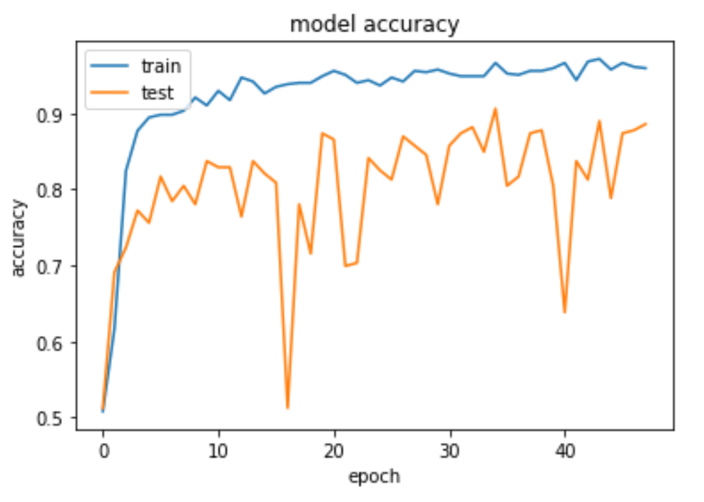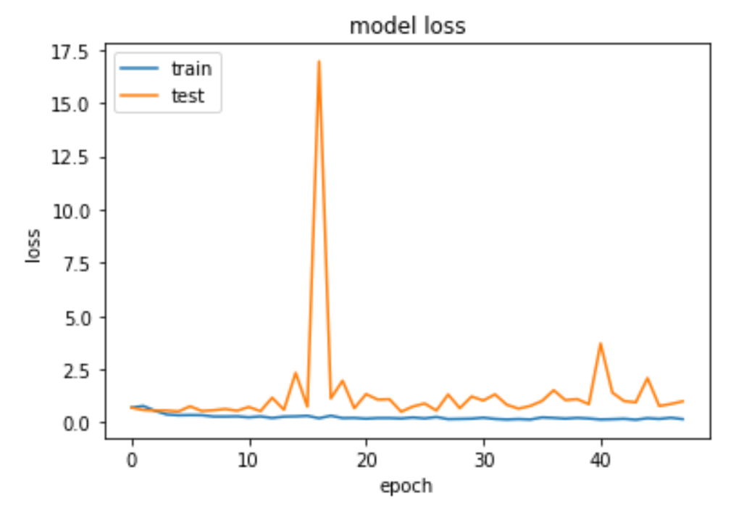

Fig. 9. Model training based on the dataset specification –

Number of COVID-19 X-ray images = 420,

Number of Normal X-ray images = 456

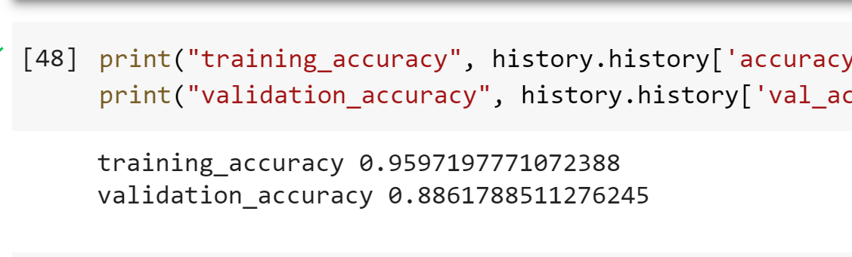

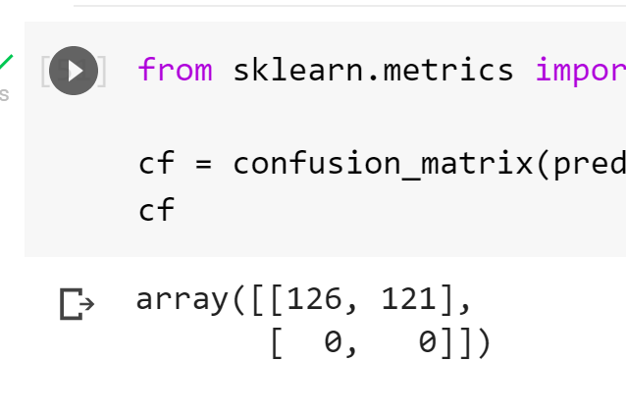 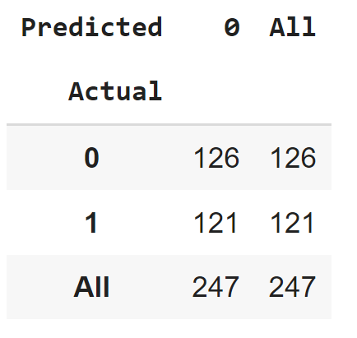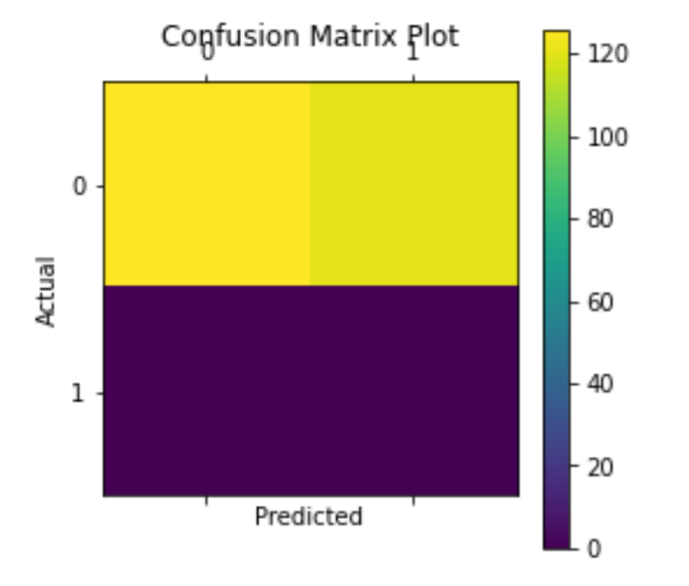

Fig. 10. Different representations of the confusion matrix

based on the dataset specification –

Number of COVID-19 X-ray images = 420,

Number of Normal X-ray images = 456

model = Sequential()

model.add(Conv2D(64, (3, 3), input_shape= (150, 150, 3)))

model.add(Activation('relu'))

model.add(MaxPooling2D(pool_size=(2, 2)))

model.add(Conv2D(64, (3, 3)))

model.add(Activation('relu'))

model.add(MaxPooling2D(pool_size=(2, 2)))

model.add(Conv2D(120,(3,3)))

model.add(Activation("relu"))

model.add(Conv2D(250,(3,3)))

model.add(Activation("relu"))

model.add(Conv2D(120,(3,3)))

model.add(Activation("relu"))

model.add(AvgPool2D(2,2))

model.add(Conv2D(256,(3,3)))

model.add(Activation("relu"))

model.add(AvgPool2D(2,2))

model.add(Flatten())

model.add(Dense(32))

model.add(Dropout(0.25))

model.add(Dense(1))

model.add(Activation("sigmoid"))

Model: "sequential_4"

_________________________________________________________________

Layer (type) Output Shape Param #

=================================================================

conv2d_26 (Conv2D) (None, 148, 148, 64) 1792

activation_30 (Activation) (None, 148, 148, 64) 0

max_pooling2d_11 (MaxPoolin (None, 74, 74, 64) 0

g2D)

conv2d_27 (Conv2D) (None, 72, 72, 120) 69240

activation_31 (Activation) (None, 72, 72, 120) 0

max_pooling2d_12 (MaxPoolin (None, 36, 36, 120) 0

g2D)

conv2d_28 (Conv2D) (None, 34, 34, 64) 69184

activation_32 (Activation) (None, 34, 34, 64) 0

conv2d_29 (Conv2D) (None, 32, 32, 250) 144250

activation_33 (Activation) (None, 32, 32, 250) 0

conv2d_30 (Conv2D) (None, 30, 30, 256) 576256

activation_34 (Activation) (None, 30, 30, 256) 0

average_pooling2d_7 (Averag (None, 15, 15, 256) 0

ePooling2D)

conv2d_31 (Conv2D) (None, 13, 13, 64) 147520

activation_35 (Activation) (None, 13, 13, 64) 0

average_pooling2d_8 (Averag (None, 6, 6, 64) 0

ePooling2D)

flatten_4 (Flatten) (None, 2304) 0

dense_8 (Dense) (None, 32) 73760

dropout_4 (Dropout) (None, 32) 0

dense_9 (Dense) (None, 1) 33

activation_36 (Activation) (None, 1) 0

=================================================================

Total params: 1,082,035

Trainable params: 1,082,035

Non-trainable params: 0

_________________________________________________________________

Fig. 11. Sequential Model Built as part of the project

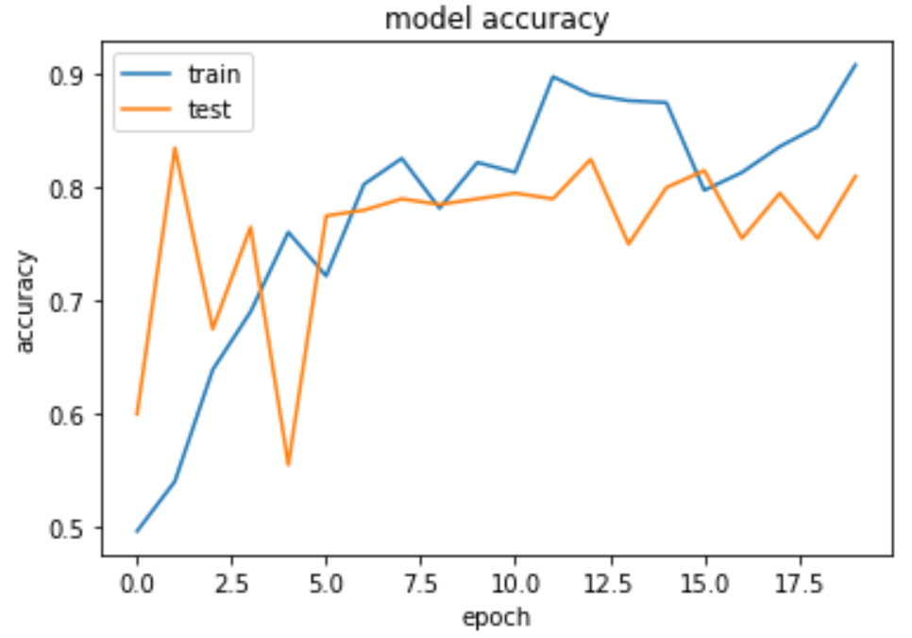 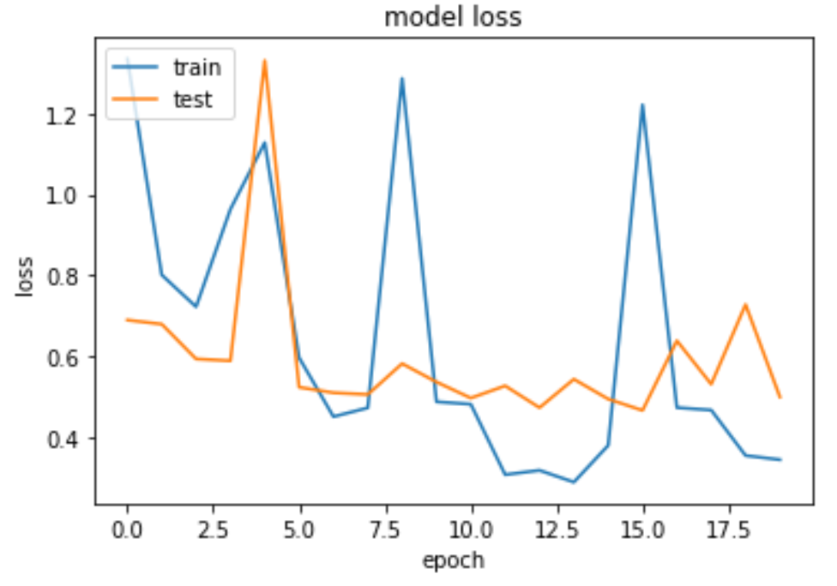

1. (B)

Fig. 12. Model training graphs for model (A) accuracy (B)

loss modified model of Section 6

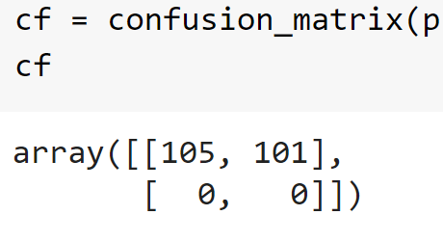 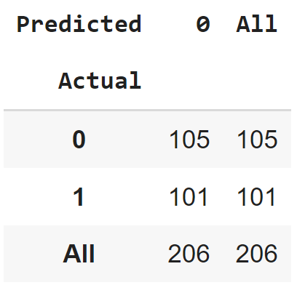 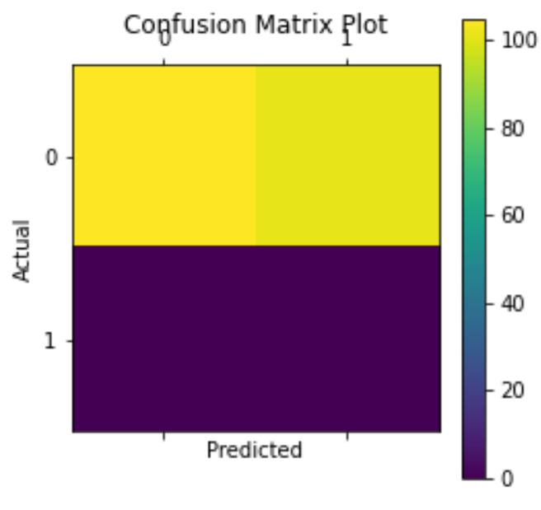

Fig. 13. Various Confusion Matrix representations for modified model of Section 6

Model: "sequential_10"

_________________________________________________________________

Layer (type) Output Shape Param #

=================================================================

conv2d_54 (Conv2D) (None, 150, 150, 32) 2432

max_pooling2d_31 (MaxPoolin (None, 75, 75, 32) 0

g2D)

conv2d_55 (Conv2D) (None, 75, 75, 64) 32832

max_pooling2d_32 (MaxPoolin (None, 37, 37, 64) 0

g2D)

conv2d_56 (Conv2D) (None, 37, 37, 120) 69240

max_pooling2d_33 (MaxPoolin (None, 18, 18, 120) 0

g2D)

conv2d_57 (Conv2D) (None, 18, 18, 64) 69184

max_pooling2d_34 (MaxPoolin (None, 9, 9, 64) 0

g2D)

flatten_10 (Flatten) (None, 5184) 0

dense_20 (Dense) (None, 512) 2654720

activation_48 (Activation) (None, 512) 0

dense_21 (Dense) (None, 1) 513

=================================================================

Total params: 2,828,921

Trainable params: 2,828,921

Non-trainable params: 0

Fig. 14. Model Built as part of this project

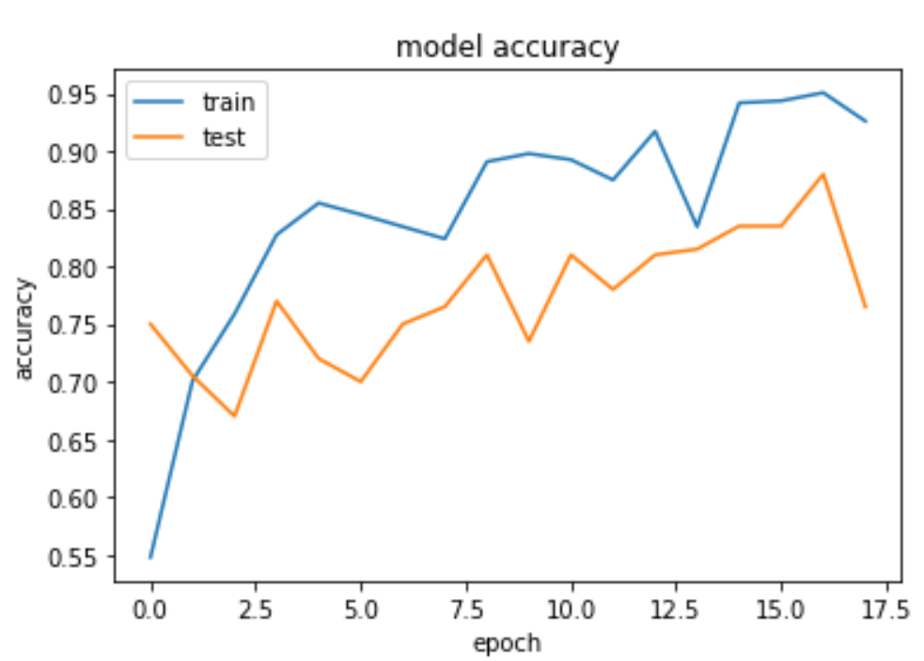 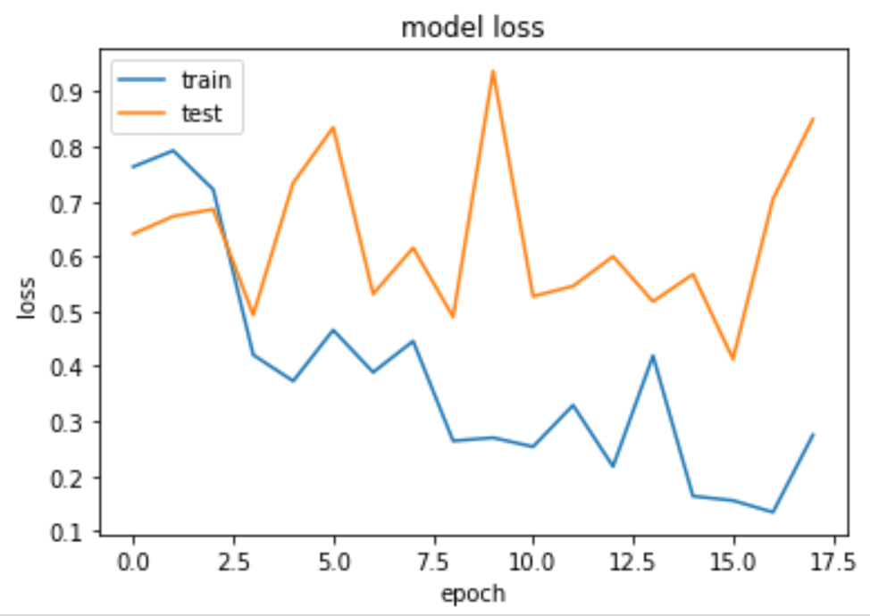

1. (B)

Fig. 15. Model training graphs for model (A) Accuracy (B)

Loss; Model built as part of this project

|  |  |  |
| --- | --- | --- |
| Akhil Srinivas Parimala | Kushagra Pathak | Puttamreddy Navyatha Reddy |
| 20BCE0567 | 20BCI0155 | 20BCT0305 |